UAT Plan
for
AeroFit

Index
1. Scope 3
1.1. Objectives and business requirements 3
1.2. Scope 3
2. Testing team 4
3. Environmental requirements 5
3.1. Hardware requirements 5
3.2. Software requirements 5
4. Test Scripts 1

Scope

Objectives and business requirements
The goal for Sprint 0.1 is to have set up a simple home page that tracks user steps and calories. The app should prompt users to “Allow Motion Permissions”, and then use motion data to show steps taken, calories burnt, and display a progress bar showing how close users are to achieving their step goals.
Scope:
AeroFit is now capable of tracking steps and calories.
For this UAT, we’d like test:
- Does launching the home page pop-up a request for Motion Permissions?
- Does clicking that request button prompt the IOS Motion and Orientation Permission alert?
- Once Motion Permissions allowed, are steps sensibly tracked. (Does stepping once increment steps by 1?)
- Is 1 Calorie burnt for every 20 Steps Taken?
- Does Step Goal progress bar appropriately increment based on step progress?
For this UAT, we are NOT testing:
- If steps aren’t tracked when standing still and shaking phone, this behavior is expected to increment the step count.
- If any data is saved when refreshing site or switching pages
- If Cal Goal progress bar works

System Diagrams
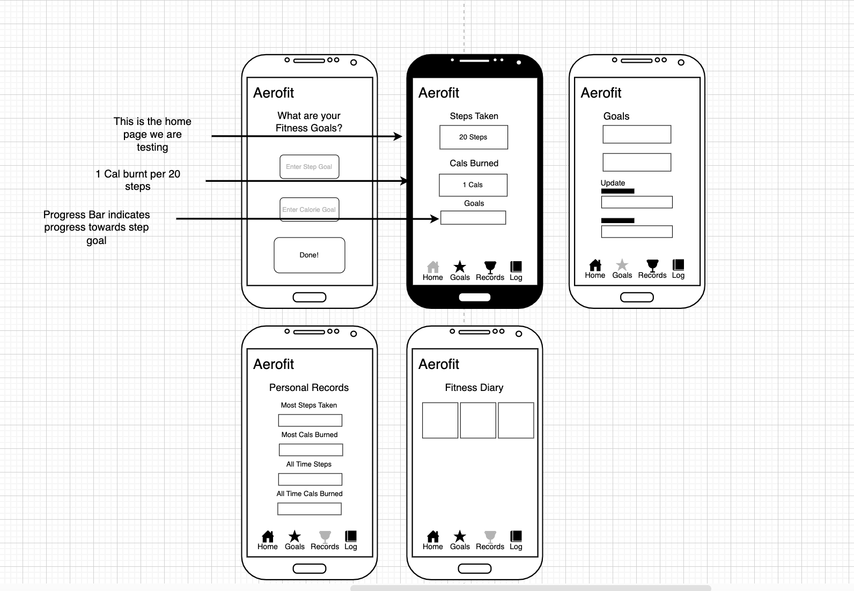

Testing team
In this section, list out members of your QA team and what their roles will be during UAT.

Name | Responsibilities
Khushal Manohar | Ensure Motion Permissions are requested and used to display sensible step + calorie counts, as well as an accurate step-goal progress bar.

Environmental requirements

Hardware requirements
- Apple iPhone 7 or newer

Software requirements
- Safari Browser (iPhone)

Network requirements.
- Standard internet connection with WWW Connectivity

Test Scripts
This section is more important than it seems—it is crucial that both the QA team and the testers know what features must be tested, especially if you’re testing a lot at once.

Test | Describe the feature being tested | Describe the user input or test data | Describe the pass criteria
1 | Motion permissions requested upon launching home page | - Navigate to https://tempehs.github.io/2024SDD-Rayan-AeroFit/index.html  - Type a number from 1-100 into both input fields and submit.  - Click on “Request Motion Permissions” and then “Allow” | - “Request Motion Permissions” Button displayed at center of screen after clicking “Submit”  - Clicking on button prompts IOS Motion and Orientation Alert.    - Clicking Allow hides “Request Motion Permissions” Button. | Tester name: Khushal Manohar  Observations:  The app asked me for motion permissions and clicking it triggered the IOS alert.
  PASS
  FAIL
2 | Step Tracking | - Once Motion Permissions are allowed, begin taking steps. | - Displayed Step Count updates in real-time and mostly correlates with real-life steps. | Tester name: Khushal Manohar  Observations:  The apps steps are mostly accurate. But steps still count when standing still and moving the phone.
  PASS
  FAIL
3 | Calorie Conversions | - Refresh home.html page to reset step data.  - Take 20 steps | - Calorie Increments by 1 for every 20 steps | Tester name: Khushal Manohar  Observations:  Yes 20 steps increased the calorie count by 1.
  PASS
  FAIL
4 | Step-Goal Progress Bar | - Ensure Step-Goal is set and not showing up as N/A.  - Refresh home.html page to reset step data.  - Start taking steps and watch goal progress bar | 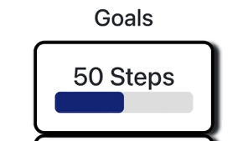  - Progress bar updates in real-time, showing step-count progress (Bar indicates percentage of the user’s step-goal completed)  E.g: Image Indicates 50% of Step Goal Complete (25 Steps Taken) | Tester name: Khushal Manohar  Observations:  The progress bar is working perfectly.
  PASS
  FAIL
Tip: Write step-by-step, detailed but concise instructions on how to test the feature.

